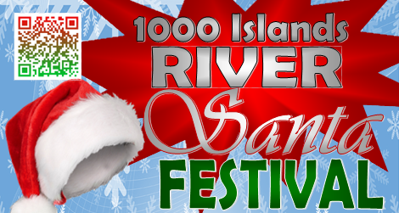

2023 Swim with Santa Event
Dec. 10, 2023

In consideration of participating in the 2023 Swim with Santa, I represent that I understand the nature of Swim with Santa Event and that I and/or my minor child am qualified, in good health, and in proper physical condition to participate in such Activity. I acknowledge that if I and/or my minor child believe event conditions are unsafe, I and/or my minor child will immediately discontinue participation in the Activity.

I fully understand that the 2023 Swim Santa involve risks of serious bodily injury, including viral infections, bacterial infections and other communicable diseases and illnesses, permanent disability, paralysis and death, which may be caused by my own actions, or inactions, those of others participating in the event, the conditions in which the event takes place, or the negligence of the "releasees" named below; and that there may be other risks either not known to me or not readily foreseeable at this time; and I fully accept and assume all such risks and all responsibility for losses, costs, and damages I and/or my minor child incur as a result of my and/or my minor child’s participation in the Activity.

I hereby release, discharge, and covenant not to sue River Santa, or the village of Alexandria its respective administrators, directors, agents, officers, volunteers, and employees, other participants, any sponsors, advertisers, and, if applicable, owners and lessors of premises on which the Activity takes place, (each considered one of the "RELEASEES" herein) from all liability, claims, demands, losses, or damages on my account caused or alleged to be caused in whole or in part by the negligence of the "releasees" or otherwise, including negligent rescue operations; and I further agree that if, despite this release, waiver of liability, and assumption of risk I, or anyone on my and/or my minor child's behalf, makes a claim against any of the Releasees, I will indemnify, save, and hold harmless each of the releasees from any loss, liability, damage, or cost which any may incur as the result of such claim.

I have read this RELEASE AND WAIVER OF LIABILITY, ASSUMPTION OF RISK, AND INDEMNITY AGREEMENT, AND PARENTAL CONSENT AGREEMENT, understand that I have given up substantial rights by signing it and have signed it freely and without any inducement or assurance of any nature and intend it be a complete and unconditional release of all liability to the greatest extent allowed by law and agree that if any portion of this agreement is held to be invalid the balance, notwithstanding, shall continue in full force and effect.
By signature below, I affirm that, in the last 14 days, I (1) have not experienced a fever 100.4 degrees or greater, a new cough, new loss of taste or smell, or shortness of breath; (2) have not received a positive result from a COVID19 test; (3) to the best of my knowledge have not been in close contact (within 6 feet for at least 10 minutes) with anyone while they had COVID-19; and (4) have not traveled to a state outside New York requiring quarantine upon reentry, nor has any member of my household.

_________________________ ____________________________
Printed name of participant Signature of Participant (only if age 18 or over)

Date: ______________________ _____________________________
Signature of Parent/Legal Guardian
(if participant under age 18)

Email: ______________________ Phone: __________________________

